

**CSE – 316**

**PROJECT PROPOSAL**

**PROJECT NAME - Car Parking System**

|  |
| --- |
| TEAM MEMBERS |
| Tunazzinur Rahman Kabbo  ID: 19202103268 |
| Imran Nazir  ID: 19202103248 |
| MD. Zobayer Hasan Nayem  ID: 19202103274 |
| Afrina Akter Mim  ID: 19202103310 |
| Rizvia Razzak Abani  ID: 19202103528 |

PRESENTED TO

**Ms. Nourin Khandaker**

*Lecturer*

Department of CSE, BUBT

**Title:** Car Parking System

**Related Work:** There are many implementations around the globe of this work. But they used complicated code and circuits.

Our project is exceptional because we’ll be using minimal and easy way to implement it. Our project will be fully controlled by two IR sensors and one Arduino Uno board.

**Methodology:** We’ll install two IR sensors, one at the outside of the gate and the other one inside of the gate. There’ll be one LCD display for showing the current state of the garage. LCD will show the remaining slots and show a message if there is no slot left. The gate will be controlled by the Servo Motor.

If one car enters the parking lot the outside IR sensor will pick that car and fill up the slot value. When a car is leaving the parking lot the inside IR sensor will pick that car’s leaving and increase the slot value. Here, one sensor will work at a time depending on which sensor is accessed first. The first sensor will get priority and the other one will pick no reading.

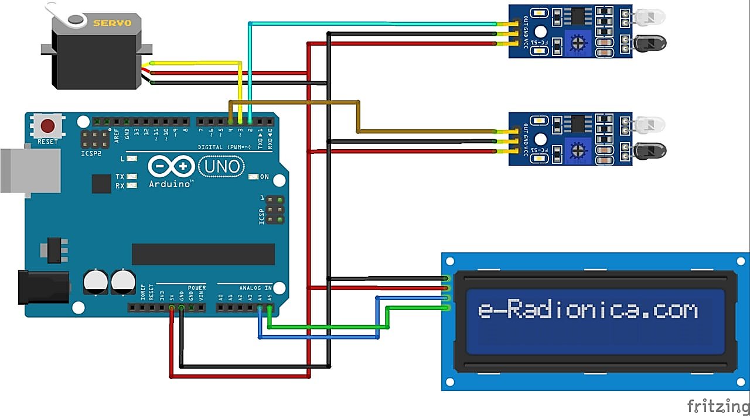

**Resources Needed:**

|  |  |
| --- | --- |
| **Components** | **Amount** |
| I2C LCD Display (16x2) | 1 |
| Arduino UNO | 1 |
| IR Sensor Module | 2 |
| Servo Motor SG91R | 1 |
| Jumper Wires (M to M & M to F) | 10-12 |

**Reference:**

* Github
* Youtube
* Google
* Tinkercad

**THANK YOU**